**University of Karachi**

**Department of Computer Science**



**Final Year Project Report**

Vehicle/Automobile Parking Security System

**Supervise by:**

**Sir Dr. Tehseen Jilani / Sir Usman Amjad**

**Submitted by:**

**Parkash Kumar (B11101067)**

**S .Haider Ali Naqvi (B10101109)**

ABSTRACT:

Automotive theft has been a persisting problem all around the Pakistan especially in our Karachi and greater challenge comes from professional thieves. In this paper, we present an automobile parking security system.

This security system is based upon machine vision / image processing technology that takes it to a new level of theft protection. It is based on hardware system, for real time acquisition of number-plate images using an active IR illuminator. This system can locate and recognize the number plate, identify the unauthorized number plate. When the unauthorized car arrives, our system will alarm and gives the option for registration of the vehicle. For being more secure we had made this live streaming as well, so that the police can see/search any vehicle in our parking area through CDMA or GPRS networks. The status of the parking field detected by sensor nodes is reported periodically to a database via the deployed wireless sensor network and its gateway. The database can be accessed by the upper layer management system to perform various management functions, such as finding vacant parking lots, auto-toll, security management, and statistic report.The system was tested in a simulating environment and it was found very robust, reliable. To prove the effectiveness of the system proposed by us we have developed and presented a mathematical model which will be discussed in brief further in the paper.

**Acknowledgement:**

I would like to express my gratitude and appreciation to all those who gave me the possibility to complete this project. A special thanks to our final year project coordinator, Sir Usman Amjad, whose help, stimulating suggestions and encouragement, helped me to coordinate my project especially in writing this report.

I would also like to acknowledge with much appreciation the crucial role of the staff of computer lab and library, who gave the permission to use all required books and the necessary material to complete this project

A special thanks goes to my team mate, Syed Ali Haider Naqvi, who helps me to complete the project and gave suggestion and innovative ideas about this project

Last but not least, many thanks go to the head of the project, Dr. Tehseen Jilani whose have given his full effort in guiding the team in achieving the goal as well as his encouragement to maintain our progress in track. I would to appreciate the guidance given by other supervisor as well as the panels especially in our project presentation that has improved our presentation skills by their comment and tips.

Table of Content

**Content Page**

1. Introduction …………………………………………………....

1.1 Project Motivation

1.2 Purpose of the System

1.3 Scope of the System

1.4 Project Objectives

1.5 Current System

1.6 Proposed System

1.7 Significance

1.8 Background

2**.** SDLC

2.1 Waterfall Model

3**.** Image Processing

3.1 Edge Detection

4. Project Overview

4.1 Registration panel

4.2 Logs

4.3 Entries

4.4 Live streaming

4.5 Notifications

4.6 Task runner

4.7 Database

4.8 Image processing using Matlab

5. Description of Hardware System

5.1 Camera

5.2 Computer/Laptop

6**.** Description of Technologies

6.1 Matlab

6.2 Nodejs

6.3 Ajax

6.4 Mongodb

# **Introduction**

# **1.1 Project Motivation.**

In many countries parking is one of the major issues and this problem is mostly faced by most of the Asian countries especially Pakistan is one which severely surround by this problem.

In Pakistan and specific in Karachi the rate of this problem is increasing which affect the rate of terrorism activities and now this problem is also facing by many universities our university is one of it.

We want to develop a “Car Parking Security System”, which trace the number plate of a car and perform the following task

1. Verify the number of a car according to records University whether it is registered or not
2. Notify the head of all monitors through email.

**1.2 Purpose of the System.**

The main theme of our project is to develop a secure car parking system based on image processing and implement on server side. The proposed application will protect the security of parking area. This application provides an efficient platform for tracking unauthorized car using matlab extract number of car and send to it on server with notification to the monitor of the entire system.

The main reason for doing this project is solve the parking problem of our university. In University of Karachi there are limited gates and number of vehicles passing through each gate, which when checked manually raises inconvenience and also to depot five to six persons on each gate. This problem is aimed to solve through this computer program.

**1.3 Scope of the System.**

The main target users for our project would be anyone this project can be placed in universities, shopping malls, hospitals, airports and can be placed anywhere. Its UI is based on web interface so don’t need any kind of installation. Our main focus to design user experience very friendly so that user can use it easily. This system is based on fully automation user just start it on one time.

# **1.4 Project Objectives.**

The core objectives which have been designated as fundamental to the project are:

1. Registration/Un-registration of the car,
2. Detection of the car,
3. Pictures of the number plate,
4. Alarm to the monitoring department,
5. Identify all the vehicles that are registered in our database and make sure that any ill-legal vehicle cannot be parked in our premises.

# **1.5 Current System.**

There are many systems and lots of security companies’ provide different kind of security.

Some provides only extracted number and some provides only desktop version. In many others there is an issue of complex UI and one of the major issue that a person who monitor

this system can easily allowed to pass unauthorized car.

# **1.6 Proposed System.**

Our system how different from others there are following points.

1. Web base UI.
2. Highly secure.
3. If monitors of car parking area allow any unauthorized car then they are also catchable because we provides mail system which send mail to the head of all monitors when any unauthorized car enters.

.

# **1.7 Significance.**

On the individual level, security is most often understood as safety. This safety includes freedom from harm, whether physical or psychological. This system is an extremely secure which creates a strong security around a property or system. It is important in maintaining security level of a building or property parking. This is boosted by the use of technological security system. It makes management centralized and easy to monitor with just the tip of a finger.

**Benefits of access control system**

· Protection of the system from unauthorized use/entry. Only authorized persons can enter into parking area

· Reduces human resource costs as all the work is done in place of the physical workforce. In addition, there is no chance of losing money as it is more secure than if human staffs were used.

· Automatic controllers operations make the system well streamlined than in human management. It gives accurate measures and counts hence avoiding any errors.

# **1.8 Background**

We took an idea from different our society and searched some books how to implement this project. We consulted our teachers for the acceptance of this project and the way we will deliver the best performance. Other than this, we noticed there is a need to develop a car parking security system which will improve parking security of our university and also reduce the risk of any terrorism activity.

# **2 SDLC**

SDLC, Software Development Life Cycle is a process used by software industry to design, develop and test high quality software. The SDLC aims to produce a high quality software that meets or exceeds customer expectations, reaches completion within times and cost estimates.

* SDLC is the acronym of Software Development Life Cycle.
* It is also called as Software development process.
* The software development life cycle (SDLC) is a framework defining tasks performed at each step in the software development process.
* ISO/IEC 12207 is an international standard for software life-cycle processes. It aims to be the standard that defines all the tasks required for developing and maintaining software.

## What is SDLC?

SDLC is a process followed for a software project, within a software organization. It consists of a detailed plan describing how to develop, maintain, replace and alter or enhance specific software. The life cycle defines a methodology for improving the quality of software and the overall development process.

The following figure is a graphical representation of the various stages of a typical SDLC.

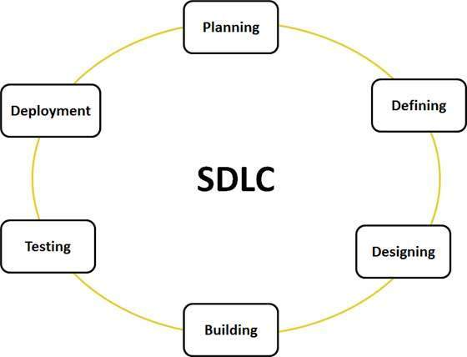

A typical Software Development life cycle consists of the following stages

## Stage 1: Planning and Requirement Analysis

Requirement analysis is the most important and fundamental stage in SDLC. It is performed by the senior members of the team with inputs from the customer, the sales department, market surveys and domain experts in the industry. This information is then used to plan the basic project approach and to conduct product feasibility study in the economical, operational, and technical areas.

Planning for the quality assurance requirements and identification of the risks associated with the project is also done in the planning stage. The outcome of the technical feasibility study is to define the various technical approaches that can be followed to implement the project successfully with minimum risks.

## Stage 2: Defining Requirements

Once the requirement analysis is done the next step is to clearly define and document the product requirements and get them approved from the customer or the market analysts. This is done through .SRS. . Software Requirement Specification document which consists of all the product requirements to be designed and developed during the project life cycle.

## Stage 3: Designing the product architecture

SRS is the reference for product architects to come out with the best architecture for the product to be developed. Based on the requirements specified in SRS, usually more than one design approach for the product architecture is proposed and documented in a DDS - Design Document Specification.

This DDS is reviewed by all the important stakeholders and based on various parameters as risk assessment, product robustness, design modularity , budget and time constraints , the best design approach is selected for the product.

A design approach clearly defines all the architectural modules of the product along with its communication and data flow representation with the external and third party modules (if any). The internal design of all the modules of the proposed architecture should be clearly defined with the minutest of the details in DDS.

## Stage 4: Building or Developing the Product

In this stage of SDLC the actual development starts and the product is built. The programming code is generated as per DDS during this stage. If the design is performed in a detailed and organized manner, code generation can be accomplished without much hassle.

Developers have to follow the coding guidelines defined by their organization and programming tools like compilers, interpreters, debuggers etc are used to generate the code. Different high level programming languages such as C, C++, Pascal, Java, and PHP are used for coding. The programming language is chosen with respect to the type of software being developed.

## Stage 5: Testing the Product

This stage is usually a subset of all the stages as in the modern SDLC models, the testing activities are mostly involved in all the stages of SDLC. However this stage refers to the testing only stage of the product where products defects are reported, tracked, fixed and retested, until the product reaches the quality standards defined in the SRS.

## Stage 6: Deployment in the Market and Maintenance

Once the product is tested and ready to be deployed it is released formally in the appropriate market. Sometime product deployment happens in stages as per the organizations. business strategy. The product may first be released in a limited segment and tested in the real business environment (UAT- User acceptance testing).

Then based on the feedback, the product may be released as it is or with suggested enhancements in the targeting market segment. After the product is released in the market, its maintenance is done for the existing customer base.

There are various software development life cycle models defined and designed which are followed during software development process. These models are also referred as "Software Development Process Models". Each process model follows a Series of steps unique to its type, in order to ensure success in process of software development. But in this project we select water fall model.

# **2.2 Waterfall Model.**

Waterfall approach was first SDLC Model to be used widely in Software Engineering to ensure success of the project. In "The Waterfall" approach, the whole process of software development is divided into separate phases. In Waterfall model, typically, the outcome of one phase acts as the input for the next phase sequentially.

Following is a diagrammatic representation of different phases of waterfall model.

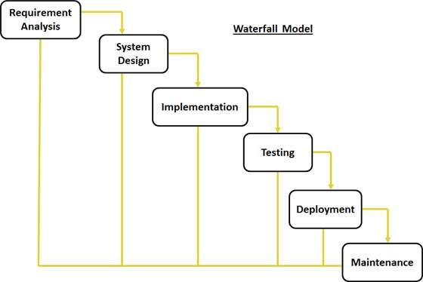

The sequential phases in Waterfall model are:

* **Requirement Gathering and analysis:** **:** All possible requirements of the system to be developed are captured and documented in a requirement specification phase. This is the most crucial part of project because the whole project depends on what we required from this system. In this part, we made our document in which we write down all specifications of our project and full information about hardware/software which will be required for making this project.
* **SystemDesign:** After documenting all gathered information in requirement specifications phase, it’s time to prepare the design of the system. An important consideration while designing parking system has been taken for the use of appropriate technology for the detection of obstacles while capturing a vehicle. There are several technologies available in the market today to solve this problem. These include various types of radar, digital camera, infrared sensors, and ultrasound sensors. Each technology has its advantages and disadvantages and, after careful consideration of all available options, we decided to use infrared sensors in our design of parking system.
* **Implementation:**
* **Interface**: For implementing the design that we make earlier, I decided to program the entrance interface in **-----** mainly for its graphical environment and ease of use. Alternatively, the interface could have been programmed in JAVA, C++ or any other object oriented programming language.
* **Code**: An implementation can be done in many ways in which we decide to code it in units form. Then by taking an input from system design, the first phase were developed in small program called a unit, which are integrated in the next phase. Each unit is developed and tested for its functionality which is referred to as Unit Testing.
* **Database**: There are several databases are available in the market like mysql, sql, mangoes dB. We decide to go with mangoes because it has some additional features over sql and other database management system and mainly it is easy to use and for future modification in databases.
* **Integration and Testing:**

1. **Integration:** All the units developed in the implementation phase are integrated into a system after testing of each unit. Post integration the entire system is tested for any faults and failures.
2. **Testing**: Each component will be tested individually before integration.
   * Compile and run Matlab program
   * Testing the interface for all user input possibilities
   * Testing the connection database for all user input possibilities

Test integrated system as each feature is added. First, I will test assuming the ideal case (one car). Next, I will simulate and test the system’s capabilities for guiding multiple cars.

* **Deployment of system:** Once the functional and non-functional testing is done, the product is deployed in the customer environment or released into the market. It is the responsibility of deployment team to install and configure this system in customer’s pc and train them how to use this system.
* **Maintenance:** There are some issues which come up in the client environment. To fix those issues patches are released. Also to enhance the product some better versions are released. Maintenance is done to deliver these changes in the customer environment.

# **3 Image Processing**

**Image processing** is a method to convert an image into digital form and perform some operations on it, in order to get an enhanced image or to extract some useful information from it. It is a type of signal dispensation in which input is image, like video frame or photograph and output may be image or characteristics associated with that image. Usually **Image Processing** system includes treating images as two dimensional signals while applying already set signal processing methods to them.

It is among rapidly growing technologies today, with its applications in various aspects of a business. Image Processing forms core research area within engineering and computer science disciplines too.

Image processing basically includes the following three steps.

·            Importing the image with optical scanner or by digital photography.

·            Analyzing and manipulating the image which includes data compression and image enhancement and spotting patterns that are not to human eyes like satellite photographs.

·            Output is the last stage in which result can be altered image or report that is based on image analysis.

**Purpose of Image processing**

The purpose of image processing is divided into 5 groups. They are:

1.      Visualization - Observe the objects that are not visible.

2.      Image sharpening and restoration - To create a better image.

3.      Image retrieval - Seek for the image of interest.

4.      Measurement of pattern – Measures various objects in an image.

5.      Image Recognition – Distinguish the objects in an image.

**Types**

The two types of methods used for Image Processing are Analog andDigital Image Processing. Analog or visual techniques of image processing can be used for the hard copies like printouts and photographs. Image analysts use various fundamentals of interpretation while using these visual techniques. The image processing is not just confined to area that has to be studied but on knowledge of analyst. Association is another important tool in image processing through visual techniques. So analysts apply a combination of personal knowledge and collateral data to image processing.

Digital Processing techniques help in manipulation of the digital images by using computers. As raw data from imaging sensors from satellite platform contains deficiencies. To get over such flaws and to get originality of information, it has to undergo various phases of processing. The three general phases that all types of data have to undergo while using digital technique are Pre- processing, enhancement and display, information extraction.

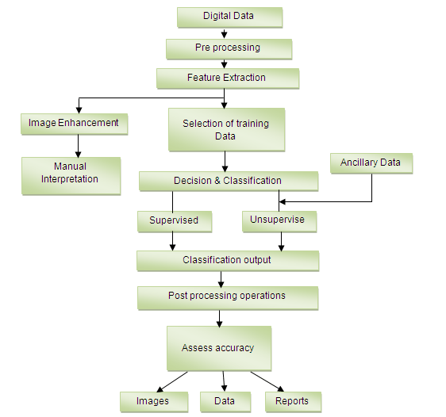

# **3.1 Edge Detection**

**Edge detection** is the name for a set of mathematical methods which aim at identifying points in a digital image at which the image brightness changes sharply or, more formally, has discontinuities. The points at which image brightness changes sharply are typically organized into a set of curved line segments termed *edges*. The same problem of finding discontinuities in 1D signals is known as step detection and the problem of finding signal discontinuities over time is known as change detection. Edge detection is a fundamental tool in image processing, machine vision and computer vision, particularly in the areas of feature detection and feature extraction

# **3.2 Other Methods for edge detection**

There are many ways to perform edge detection. However, the most may be grouped into two categories, gradient and Laplacian. The gradient method detects the edges by looking for the maximum and minimum in the first derivative of the image. The Laplacian method searches for zerocrossings in the second derivative of the image to find edges. This first figure shows the edges of an image detected using the gradient method (Roberts, Prewitt, Sobel) and the Laplacian method (Marrs-Hildreth).

|  |
| --- |
| http://www.owlnet.rice.edu/~elec539/Projects97/morphjrks/kfig1.jpg  **Various Edge Detection Filters** |

Notice that the facial features (eyes, nose, mouth) have very sharp edges. These also happen to be the best reference points for morphing between two images. Notice also that the Marr-Hildreth not only has a lot more noise than the other methods, the low-pass filtering it uses distorts the actual position of the facial features. Due to the nature of the Sobel and Prewitt filters we can select out only vertical and horizontal edges of the image as shown below. This is very useful since we do not want to morph a vertical edge in the initial image to a horizontal edge in the final image. This would cause a lot of warping in the transition image and thus a bad morph.

|  |
| --- |
| http://www.owlnet.rice.edu/~elec539/Projects97/morphjrks/kfig2.jpg  Vertical and Horizontal Edges |

The next pair of images show the horizontal and vertical edges selected out of the group members images with the Sobel method of edge detection. You will notice the difficulty it had with certain facial features, such as the hairline of Sri and Jim. This is essentially due to the lack of contrast between their hair and their foreheads.

|  |
| --- |
| http://www.owlnet.rice.edu/~elec539/Projects97/morphjrks/kfig3.jpgVertical Sobel Filter Horizontal Sobel Filter |

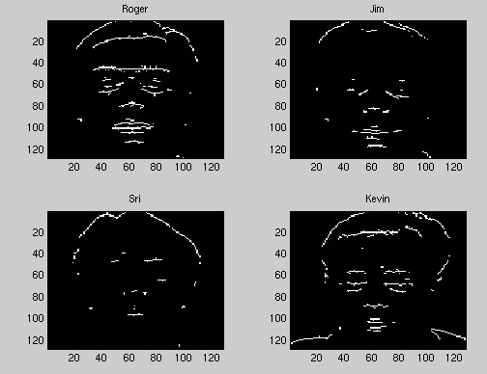We can then compare the feature extraction using the Sobel edge detection to the feature extraction using the Laplacian.

|  |
| --- |
| http://www.owlnet.rice.edu/~elec539/Projects97/morphjrks/kfig8a.jpg Sobel Filtered Common Edges http://www.owlnet.rice.edu/~elec539/Projects97/morphjrks/kfig8b.jpg Sobel Filtered Common Edges |

We see that although it does do better for some features (ie. the nose), it still suffers from mis mapping some of the lines. A morph constructed using individually selected points would still work better. It should also be noted that this method suffers the same drawbacks as the previous page; difficulties due to large contrast between images and the inability to handle large translations of features. Another method of detecting edges is using wavelets. Specifically a two-dimensional Haar wavelet transform of the image produces essentially edge maps of the vertical, horizontal, and diagonal edges in an image.

This can be seen in the figure of the transform below, and the following figure where we have combined them to see the edges of the entire face.

And here are the maps of common control points generated by the feature extraction algorithm for the Jim-Roger morph.

|  |
| --- |
| http://www.owlnet.rice.edu/~elec539/Projects97/morphjrks/kfig9b.jpghttp://www.owlnet.rice.edu/~elec539/Projects97/morphjrks/kfig9a.jpgHaar FilteredCommon Edges |

# **4 Project Overview**

# 4.1 Registration panel

# 4.2 Logs

# 4.3 Entries

# 4.4 Live Streaming

# 4.5 Notifications

# 4.6 Task runner

# 4.7 Database

Gulp is continuously watching notepad file and restarts server

Matlab is extracting number plate of car

Notepad file

Nodejs server reads changes from notepad file and stores in db

Database

# **4.1 Registration Panel**

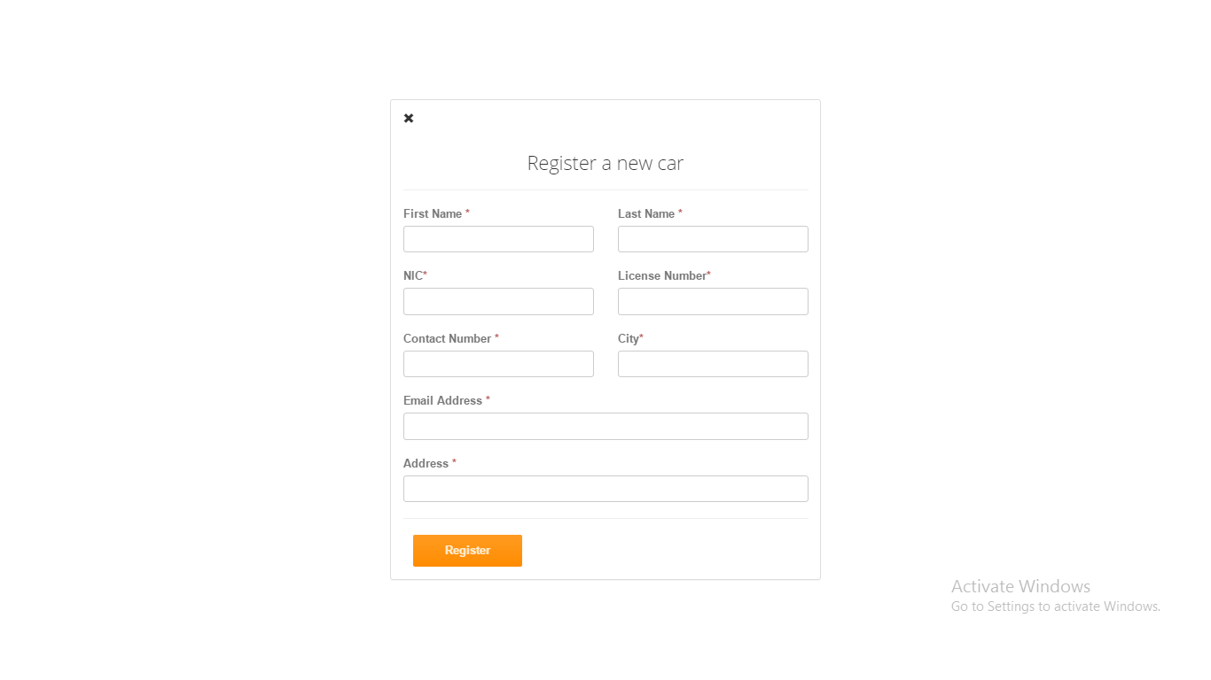

This is the registration panel it used to register new entry of car. All fields are necessary to fill except email. Every entry’s detail sends to that person who monitors this complete system.

**CodeSnippet**

<form action="/" method="POST">

<div class="row top-margin">

<div class="col-sm-6">

<label>First Name <span class="text-danger">*</span></label>

<input type="text" class="form-control" name="firstname">

</div>

<div class="col-sm-6"><label>Last Name <span class="text-danger">*</span></label>

<input type="text" class="form-control" name="lastname">

</div>

</div>

<div class="row top-margin">

<div class="col-sm-6">

<label>NIC<span class="text-danger">*</span></label>

<input type="number" class="form-control" name="nic">

</div>

<div class="col-sm-6">

<label>License Number<span class="text-danger">*</span></label>

<input type="text" class="form-control" name="licensenumber">

</div>

</div>

<div class="row top-margin">

<div class="col-sm-6">

<label>Contact Number <span class="text-danger">*</span></label>

<input type="number" class="form-control" name="contactnumber">

</div>

<div class="col-sm-6">

<label>City<span class="text-danger">*</span></label>

<input type="text" class="form-control" name="city">

</div>

</div>

<div class="top-margin">

<label>Email Address <span class="text-danger">*</span></label>

<input type="email" class="form-control" name="email">

</div>

<div class="top-margin">

<label>Address <span class="text-danger">*</span></label>

<input type="text" class="form-control" name="address">

</div>

<hr>

<div class="row"><div class="col-lg-4 text-right">

<button class="btn btn-action" type="submit">Register</button>

</div>

</div>

</form>

# **4.2 Logs**

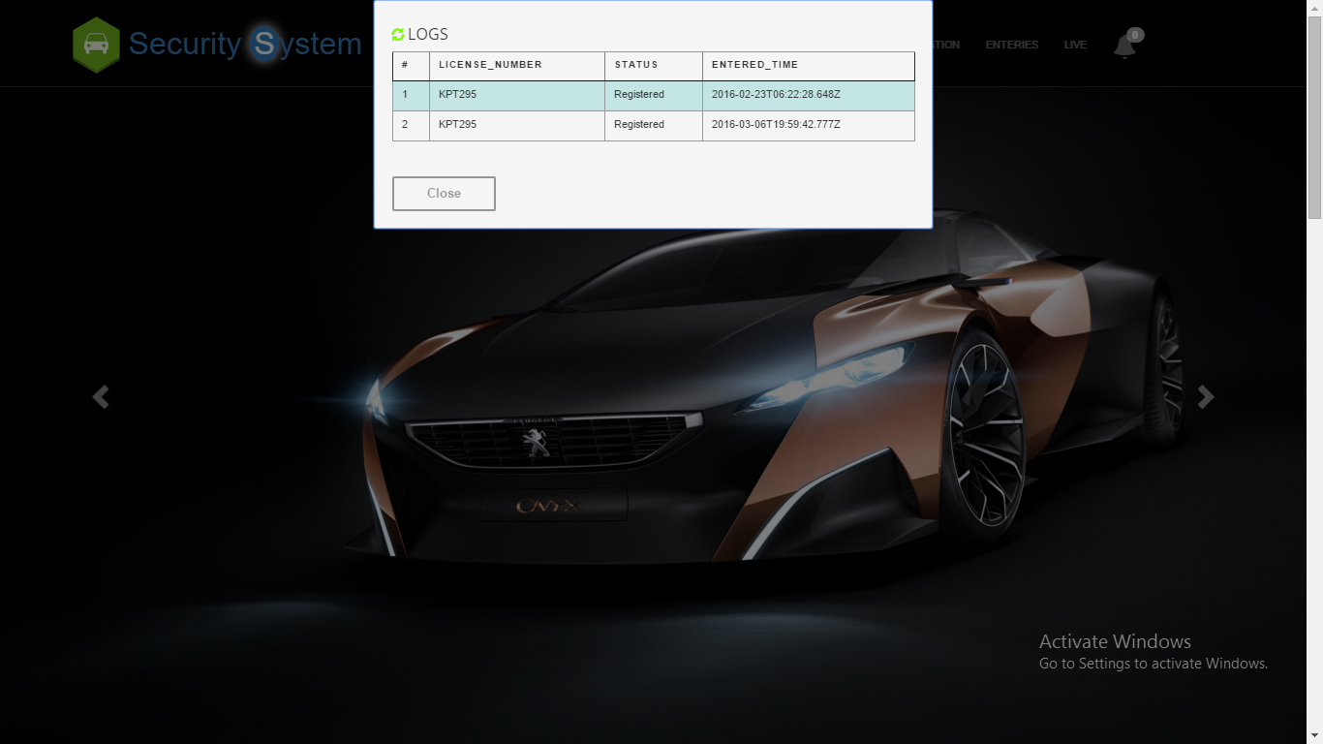

This area shows daily entries of cars whether it is register or unregister and these logs are clear automatically after one day.

**CodeSnippet**

<div id="slide" class="well">

<span id="refresh" onclick="ajaxCall()">

<i class="glyphicon glyphicon-refresh"></i>

<h4>LOGS</h4><br/></span>

<table id="hor-minimalist-a" summary="Employee Pay Sheet" class="scroll prettyprint" border="1">

<thead>

<tr>

<th scope="col">#</th>

<th scope="col">License_Number</th>

<th scope="col">Status</th>

<th scope="col">Entered_Time</th>

</tr>

</thead>

<tbody id='row-data'>

</tbody>

</table>

<br><br>

<button class="slide_close btn btn-default">Close</button>

<script>

$(document).ready(function () {

$('#slide').popup({

focusdelay: 400,

outline: true,

vertical: 'top'

});

});

var logs= <%- logs %>

var count=[];

for(var i=0;i<logs.length;i++){

if(logs[i].status=="Unregistered"){

count.push(logs[i].status);

}

}

$('#count').append(count.length);

if(logs==" "){}

else{

for(var i=0;i<logs.length;i++){

$('#row-data').append(

"<tr class='even' >"

+"<td>"+(i+1)+"</td>"

+"<td>"+logs[i].plateNumber+"</td>"

+"<td class='logs'>"+logs[i].status+"</td>"

+"<td>"+logs[i].createdOn+"</td>"

+"</tr>")

}

console.log(logs);

}

//setInterval(ajaxCall, 3000); //300000 MS == 5 minutes

function dummy(){console("ok");

}

function ajaxCall() {

document.getElementById('row-data').innerHTML=" "

document.getElementById('count').innerHTML=" "

var data={"number":"AXZ-420","EnteringTime":Date()}

$.ajax({

type: 'GET',

data: data,

cache: false,

contentType: 'application/json',

datatype: "json",

url: '/fetch',

success: function (logs) {

var _data=JSON.parse(logs);

// console.log( _data);

//$.notify(_data,"warning");

for(var i=0;i<_data.length;i++){

$('#row-data').append(

"<tr class='even' >"

+"<td >"+(i+1)+"</td>"

+"<td >"+_data[i].plateNumber+"</td>"

+"<td class='logs'>"+_data[i].status+"</td>"

+"<td >"+_data[i].createdOn+"</td>"+"</tr>")}

var count=[];

for(var i=0;i<_data.length;i++){

if(_data[i].status=="Unregistered"){

count.push(_data[i].status);

}

}

$('#count').append(count.length);

console.log($('#count').text())

if(($('#count').text())>0){

$('#count').css('background','red');

var audio = document.getElementById("audio");

audio.play();

//alert("Hey..... Unauthorized car has detected take some action", function() { });

} } });}

if(($('#count').text())==0){

$('#count').css('background','#9d9d9d');

}

if(($('#count').text())>0){

var audio = document.getElementById("audio");

//audio.play();

bootbox.alert("Hey..... Unauthorized car has detected take some action", function() { });

}

setInterval(warn,100000);

function warn(){

if(($('#count').text())>0){

$('#count').css('background','red');

var audio = document.getElementById("audio");

audio.play();

bootbox.alert("Hey..... Unauthorized car has detected take some an action", function() { });

}

}

var col=$(".logs");

for(var i=0 ;i<col.length; i++)

{

if(col[i].innerText=='Unregistered'){

var _i = document.createElement("i");

col[i].appendChild(_i);

//console.log(col[i]);}}

</script>

</script>

# **4.3 Entries**

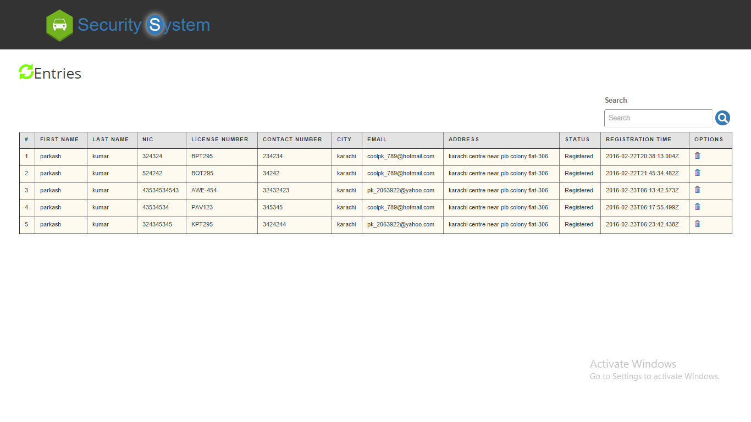

This area shows complete details of register car with some options i.e search and delete user can search specific record and also delete any record

**CodeSnippet**

<div id="fade" class="well1">

<i class='fade_close glyphicon glyphicon-remove' ></i>

<span id="refresh" onclick="enteriesAjaxCall()">

<i class="glyphicon glyphicon-refresh"></i>

<h4>Entries</h4><br/><span>

<table id="hor-minimalist-a" summary="Employee Pay Sheet" class="scroll prettyprint entriestable" border="1" >

<thead class="entry-head">

<tr>

<th scope="col">#</th>

<th scope="col">First Name</th>

<th scope="col">Last Name</th>

<th scope="col">NIC</th>

<th scope="col">License Number</th>

<th scope="col">Contact Number</th>

<th scope="col">City</th>

<th scope="col">Email</th>

<th scope="col">Address</th>

<th scope="col">Status</th>

<th scope="col">Registration Time</th>

<th scope="col">Options</th>

</tr>

</thead>

<tbody id='row-data-enteries' class="entry-body">

</tbody>

</table>

</div>

<script>

$(document).ready(function () {

$('#fade').popup({

transition: 'all 0.3s',

scrolllock: true

});

});

function enteriesAjaxCall() {

document.getElementById('row-data-enteries').innerHTML=" "

document.getElementById('count').innerHTML=" "

var data={"number":"AXZ-420","EnteringTime":Date()}

$.ajax({

type: 'GET',

data: data,

cache: false,

contentType: 'application/json',

datatype: "json",

url: '/enteries',

success: function (logs) {

var _data=JSON.parse(logs);

console.log( _data);

//$.notify(_data,"warning");

for(var i=0;i<_data.length;i++){

if(_data!=" "){

$('#row-data-enteries').append(

"<tr class='even' >"

+"<td>"+(i+1)+"</td>"

+"<td>"+_data[i].firstname+"</td>"

+"<td>"+_data[i].lastname+"</td>"

+"<td>"+_data[i].nic+"</td>"

+"<td>"+_data[i].licenseNumber+"</td>"

+"<td>"+_data[i].contactNumber+"</td>"

+"<td>"+_data[i].city+"</td>"

+"<td>"+_data[i].email+"</td>"

+"<td>"+_data[i].address+"</td>"

+"<td>"+_data[i].status+"</td>"

+"<td>"+_data[i].createdOn+"</td>"

+"<td><a href='' id="+_data[i]._id+" onclick='deleteAjaxCall(id)'><i class='glyphicon glyphicon-trash'></i></a></td>"

+"</tr>")

}

} }

});}

function deleteAjaxCall(id) {

var data={"id":id};

console.log(data);

$.ajax({

type: 'GET',

data: data,

cache: false,

contentType: 'application/json',

datatype: "json",

url: '/delete',

success: function (logs) {

var _data=JSON.parse(logs);

bootbox.alert("Record Deleted", function() { });

}});

}

</script>

# **4.4 Live Streaming**

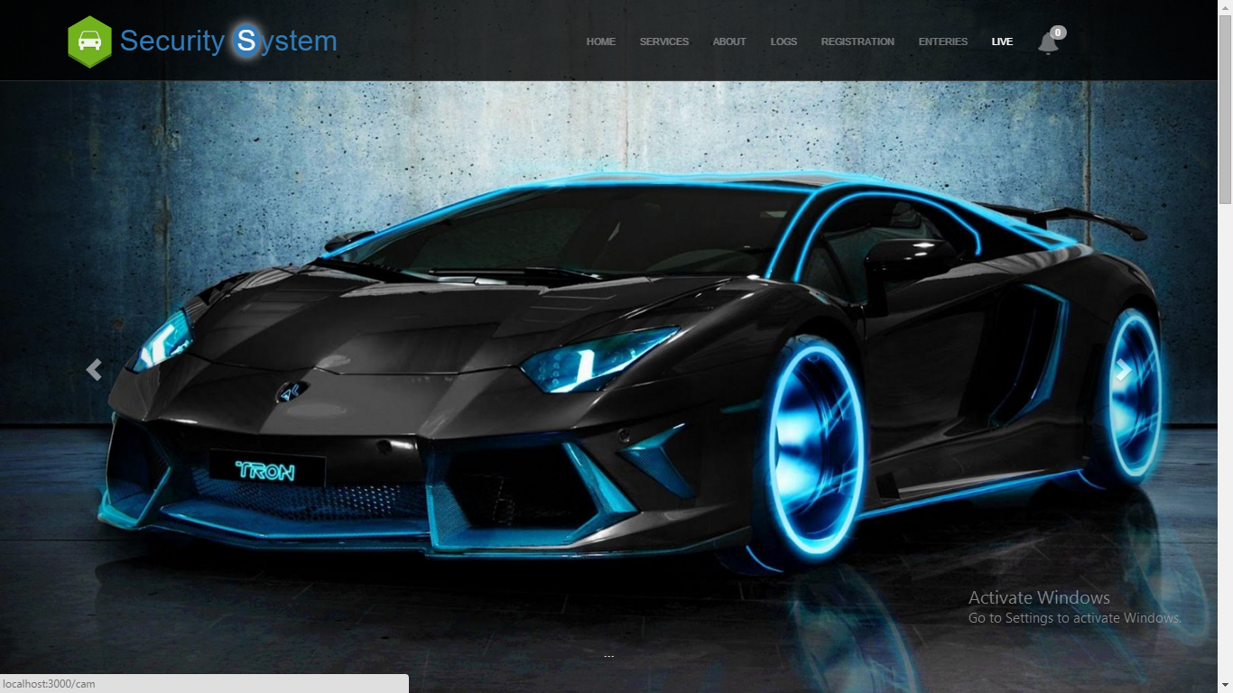

With the help of live streaming any member of security can see the entries of cars

**CodeSnippet**

<!Doctype html>

<html>

<head>

<title>

</title>

<style>

#canvas {

margin-top: 20px;

border: 1px solid #ccc;

display: inline-block;

margin-right:4em;

}

</style>

</head>

<body>

<video id="video" width="640" height="480" autoplay></video>

<canvas id="canvas" width="640" height="480" x="640"></canvas><br/>

<button id="snap">Snap Photo</button>

</body>

<script>

// Put event listeners into place

window.addEventListener("DOMContentLoaded", function() {

// Grab elements, create settings, etc.

var canvas = document.getElementById("canvas"),

context = canvas.getContext("2d"),

video = document.getElementById("video"),

videoObj = { "video": true },

errBack = function(error) {

console.log("Video capture error: ", error.code);

};

// Put video listeners into place

if(navigator.getUserMedia) { // Standard

navigator.getUserMedia(videoObj, function(stream) {

video.src = stream;

video.play();

}, errBack);

} else if(navigator.webkitGetUserMedia) { // WebKit-prefixed

navigator.webkitGetUserMedia(videoObj, function(stream){

video.src = window.URL.createObjectURL(stream);

video.play();

}, errBack);

}

else if(navigator.mozGetUserMedia) { // Firefox-prefixed

navigator.mozGetUserMedia(videoObj, function(stream){

video.src = window.URL.createObjectURL(stream);

video.play();

}, errBack);

}

document.getElementById("snap").addEventListener("click", function() {

context.drawImage(video, 0, 0, 640, 480);

});

}, false);

</script>

</html>

# **4.5 Notifications**



This shows the number of unregistered car entered in the parking area by default its color is grey but when unregistered car is detected it turns into red.

**CodeSnippet**

<li><a class="font-horn" ><i class="glyphicon glyphicon-bell" data-toggle="tooltip" data-placement="bottom" title="Unregistered Entries"></i><span class="badge" id="count"></span></a></li>

var count=[];

for(var i=0;i<_data.length;i++){

if(_data[i].status=="Unregistered"){

count.push(_data[i].status);

}

}

$('#count').append(count.length);

//console.log(data);

console.log($('#count').text())

if(($('#count').text())>0){$('#count').css('background','red');

# **4.6 Task Runner**

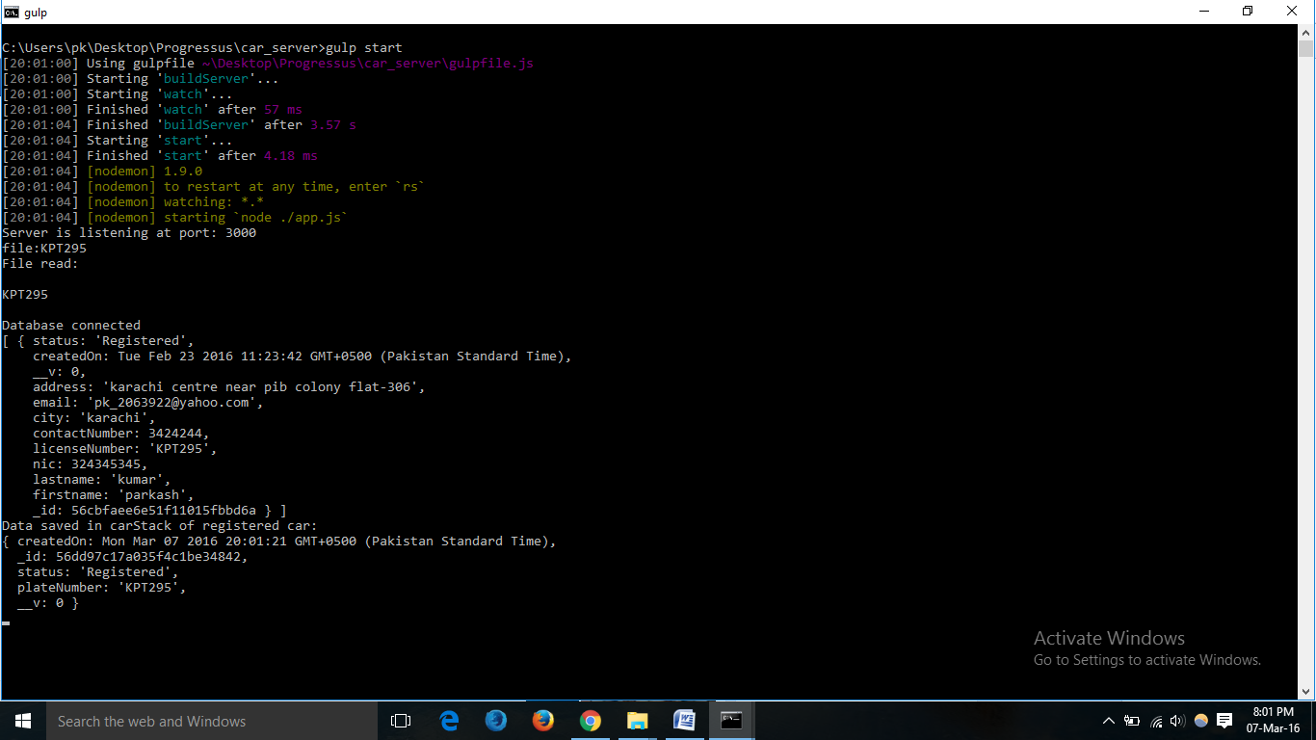

Gulp is used as a task runner which automatically restarts server and updates database. It is continously watching notepad file where extracted number is stored.

**CodeSnippet**

var gulp = require('gulp');

var ts = require('gulp-typescript');

var rimraf = require('gulp-rimraf');

var nodemon = require('gulp-nodemon');

gulp.task('buildServer', function () {

var tsResult = gulp.src('./app.ts')

.pipe(ts({

module: 'CommonJS'

}));

return tsResult.js.pipe(gulp.dest('./'));

});

gulp.task('start', ['buildServer', 'watch'], function(){

nodemon({

script: './app.js',

text:'./numberPlate.txt'

}).on('restart', function(){

console.log('nodemon restarted server.js');

})

})

gulp.task('watch', function() {

gulp.watch(['./app.ts','./numberPlate.txt'], ['buildServer']);

});

gulp.task('default', ['buildServer']);

gulp.task('open', function(){

var options = {

uri: 'localhost:3000',

app: 'chrome'

};

gulp.src('./app.js')

.pipe(open(options));

});

gulp.task('browser', ['start'], function() {

browserSync.init(null, {

proxy: "http://localhost:3000",

files: ["./*.txt"],

browser: "google chrome",

port: 5000,

});

});

gulp.task('open', function(){

var options = {

uri: 'localhost:3000',

app: 'chrome'

};

gulp.src('./app.js')

.pipe(open(options));

});

# **4.7 Database**

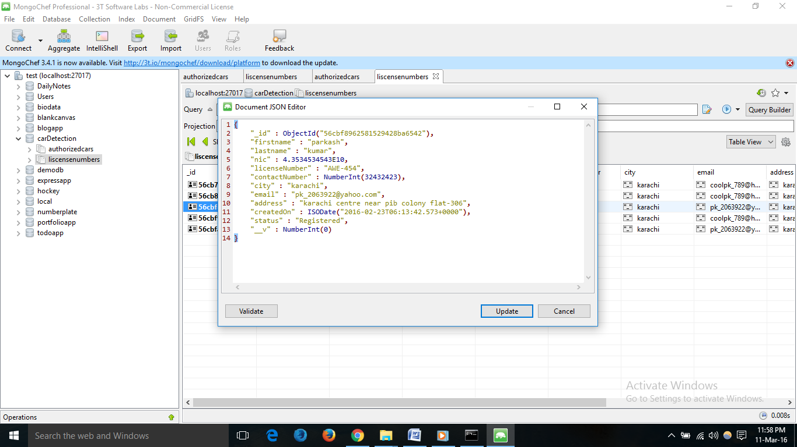

Mongodb stores data in JSON format and this is the json of document of registered car.

**CodeSnippet**

var mongoose=require('mongoose');

//connection string

var dburi="mongodb://127.0.0.1/carDetection";

mongoose.connect(dburi);

//verifying connection

mongoose.connection.on('connected',function () {

console.log("Database connected");

});

mongoose.connection.on('error',function (err) {

console.log("Error in db connection:\n"+err);

});

//Database schema

var car=mongoose.Schema({

"firstname":{type:String,required:true},

"lastname":{type:String,required:true},

"nic":{type:Number,required:true,unique:true},

"licenseNumber":{type:String,required:true,unique:true},

"contactNumber":{type:Number,required:true},

"city":{type:String,required:true},

"email":{type:String},

"address":{type:String,required:true},

"status":{type:String,default:"Registered"},

"createdOn":{type:Date,default:Date.now()}

})

var trackCar=mongoose.Schema({

"plateNumber":{type:String},

"status":{type:String },

"createdOn":{type:Date,default:Date.now()} ,})

//Database Model

var liscenseNumber=mongoose.model('liscenseNumber',car);

var AuthorizedCar=mongoose.model('AuthorizedCar',trackCar);

var carStack=new AuthorizedCar({

"plateNumber":num,

"status":"Unregistered",

"createdOn":Date.now() ,

}).save(function(err,data){

var result=data;

if(err)console.log("Error to maintain data of unregistered car: \n"+err);

else{

console.log("Data saved in carStack of unregistered car: \n"+data);

var mailOptions = {

from: "RedZone Security Systems pkbscs67@gmail.com", // sender address

to: "pk_bscs@yahoo.com", // list of receivers

subject: "Alert...Unregistered car detected", // Subject line

text:"Unregistered car of number is: "+data.plateNumber

// plaintext body

// html body}

// send mail with defined transport object

// send mail with defined transport object

transporter.sendMail(mailOptions, function(error, info){

if(error){

return console.log(error);}

console.log('Message sent: ' + info.response);});}})}

app.post('/',function (req,res) {

var car_entry=new liscenseNumber({

"firstname":req.body.firstname,

"lastname":req.body.lastname,

"nic":req.body.nic,

"licenseNumber":req.body.licensenumber,

"contactNumber":req.body.contactnumber,

"city":req.body.city,

"email":req.body.email,

"address":req.body.address,

"status":"Registered",

"createdOn":Date.now()

}).save(function(err,data){

if(err)console.log("Data is not inserted: \n"+err);

else{

console.log("Data inserted: \n"+data);

var result=JSON.stringify(data);

var mailOptions = {

from: "RedZone Security Systems pkbscs67@gmail.com", // sender address

to: "pk_bscs@yahoo.com", // list of receivers

subject: "New Registration", // Subject line

text:"firstname: "+req.body.firstname+"\n"

+"lastname: "+req.body.lastname+"\n"

+"NIC: "+req.body.nic+"\n"

+"licenseNumber: "+req.body.licensenumber+"\n"

+"contactNumber: "+req.body.contactnumber+"\n"

+"city: "+req.body.city+"\n"

+"email: "+req.body.email+"\n"

+"address: "+req.body.address+"\n" }

transporter.sendMail(mailOptions, function(error, info){

if(error){

return console.log(error);

}console.log('Message sent: ' + info.response);});

res.redirect('/'); }})});

var carStack=new AuthorizedCar({

"plateNumber":data[i].licenseNumber,

"status":data[i].status,

"createdOn":Date.now() ,

}).save(function(err,data){

if(err)console.log("Error to maintain data of registered car: \n"+err);

else{

console.log("Data saved in carStack of registered car: \n"+data);}})

# **4.8 Image Processing Using Matlab**

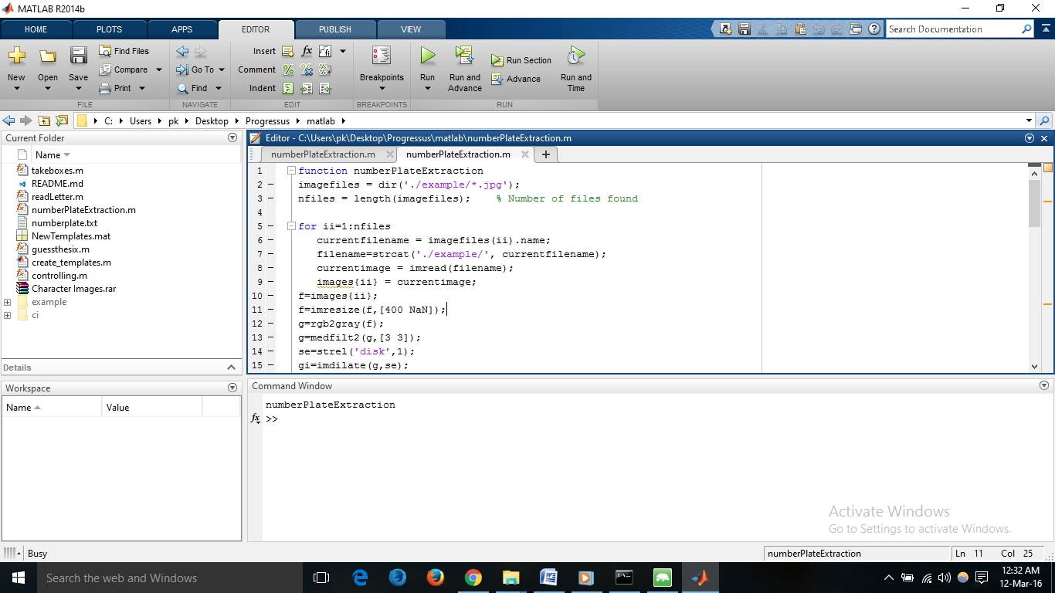

**CodeSnippet**

function numberPlateExtraction

imagefiles = dir('./example/*.jpg');

nfiles = length(imagefiles); % Number of files found

for ii=1:nfiles

currentfilename = imagefiles(ii).name;

filename=strcat('./example/', currentfilename);

currentimage = imread(filename);

images{ii} = currentimage;

f=images{ii};

f=imresize(f,[400 NaN]);

g=rgb2gray(f);

g=medfilt2(g,[3 3]);

se=strel('disk',1);

gi=imdilate(g,se);

ge=imerode(g,se);

gdiff=imsubtract(gi,ge);

gdiff=mat2gray(gdiff);

gdiff=conv2(gdiff,[1 1;1 1]);

gdiff=imadjust(gdiff,[0.5 0.7],[0 1],0.1);

B=logical(gdiff);

er=imerode(B,strel('line',50,0));

out1=imsubtract(B,er);

F=imfill(out1,'holes');

H=bwmorph(F,'thin',1);

H=imerode(H,strel('line',3,90));

final=bwareaopen(H,100);

Iprops=regionprops(final,'BoundingBox','Image');

NR=cat(1,Iprops.BoundingBox);

r=controlling(NR);

if ~isempty(r)

I={Iprops.Image};

noPlate=[];

for v=1:length(r)

N=I{1,r(v)};

letter=readLetter(N);

while letter=='O' || letter=='0'

if v<=3

letter='O';

else

letter='0';

end

break;

end

noPlate=[noPlate letter];

end

fid = fopen('../car_server/numberPlate.txt','w');

fprintf(fid,'\n%s \n\r',noPlate);

fclose(fid);

winopen('../car_server/numberPlate.txt')

else

fprintf('Unable to extract the characters from the number plate.\n');

fprintf('The characters on the number plate might not be clear or touching with each other or boundries.\n');

end

pause(10);

end

end

# **5 Description of Hardware System**

# **5.1 CCTV / IP / IR Camera**

IP camera is used to capture image of car so that we number can be extracted number plate of car.

IP camera, is a type of digital video camera commonly employed for surveillance, and which, unlike analog closed circuit television (CCTV) cameras, can send and receive data via a computer network and the Internet. Although most cameras that do this are webcams, the term "IP camera" or "netcam" is usually applied only to those used for surveillance.

# **5.2 Computer or Laptop**

A computer or laptop is required to monitor or run the enitre security system. The hardware requirements which you are need to install this software.

|  |  |
| --- | --- |
| Operating System | Windows 7 + |
| Ram | 1GB |
| Space | 512mb |

# **6 Description of Technologies.**

# **6.1 What is Matlab?**

In [computer programming](https://en.wikipedia.org/wiki/Computer_programming), **Matlab** is an [integrated development environment](https://en.wikipedia.org/wiki/Integrated_development_environment) (IDE). It contains a base [workspace](https://en.wikipedia.org/wiki/Workspace) and an extensible [plug-in](https://en.wikipedia.org/wiki/Plug-in_(computing)) system for customizing the environment. It developed a proprietary programming language that allows matrix manipulations, plotting of functions and data, implementation of algorithms, creation of user interfaces, and interfacing with programs written in other languages, including C, C++, Java, Fortran and Python.

# **Interface**

MATLAB is a [multi-paradigm](https://en.wikipedia.org/wiki/Multi-paradigm_programming_language) [numerical computing](https://en.wikipedia.org/wiki/Numerical_analysis) environment and [fourth-generation programming language](https://en.wikipedia.org/wiki/Fourth-generation_programming_language). It supports developing applications with [graphical user interface](https://en.wikipedia.org/wiki/Graphical_user_interface) (GUI) features.GUI provide point-and-click control of software applications, eliminating the need to learn a language or type commands in order to run the application. MATLAB apps are self-contained MATLAB programs with GUI front ends that automate a task or calculation. The GUI typically contains controls such as menus, toolbars, buttons, and sliders. Many MATLAB products, such as Curve Fitting Toolbox, Signal Processing Toolbox, and Control System Toolbox, include apps with custom user interfaces. You can also create your own custom apps, including their corresponding UIs, for others to use.

# **Application workflow**

This application is basically divided into parts client-side and server-side. Client side consist on matlab and web-based user interface whereas on server side requests are handle by nodejs sever.

1. Gulp: It is task runner which is used to start nodejs server and continously watching any change in notepad file which stores number extracted from number plate of a car. If any change occurs in notepad file then it automatically restarts our server.

1. Matlab: It is used to extract number from a number plate of car and stores in a notepad file.
2. Nodejs: It is used to handle requests and extract number from a notepad file and stores in a database
3. Mongodb: It is used to store details of a car and daily entries.
4. Logs: It is an area in web where user can see all daily entries.
5. Ajax: Whenever new car is entered number is extracted in a notepad file through matlab and server gets restart with the help of gulp when server restarts an ajax request is triggered to nodejs server that checks the entered car number in a database if it is not present then marked is as an unregistered car.
6. Nodemailer: Whenever new license number is detect a mail is sent to a user with complete details of car

Gulp is continuously watching notepad file and restarts server

Matlab is extracting number plate of car

Notepad file

Nodejs server reads changes from notepad file and stores in db

Database

# **6.2 What is Nodejs?**

Node.js is an [open-source](https://en.wikipedia.org/wiki/Open-source_software), [cross-platform](https://en.wikipedia.org/wiki/Cross-platform) [runtime environment](https://en.wikipedia.org/wiki/Runtime_system) for developing [server-side](https://en.wikipedia.org/wiki/Server-side) [Web applications](https://en.wikipedia.org/wiki/Web_application). Node.js is a platform built on Chrome’s JavaScript runtime for easily building fast and scalable network applications. Node.js uses an event-driven, non-blocking I/O model that makes it lightweight and efficient, perfect for data-intensive real-time applications that run across distributed devices. It’s not a [JavaScript framework](https://en.wikipedia.org/wiki/JavaScript_framework) but many of its basic modules are written in [JavaScript](https://en.wikipedia.org/wiki/JavaScript), and developers can write new modules in JavaScript. The runtime environment interprets JavaScript using [Google](https://en.wikipedia.org/wiki/Google)'s [V8](https://en.wikipedia.org/wiki/V8_(JavaScript_engine)) JavaScript engine.

# **Main Features**

Following are some of the important features that make Node.js the first choice of software architects.

* **Asynchronous and Event Driven** All APIs of Node.js library are asynchronous that is, non-blocking. It essentially means a Node.js based server never waits for an API to return data. The server moves to the next API after calling it and a notification mechanism of Events of Node.js helps the server to get a response from the previous API call.
* **Very Fast** Being built on Google Chrome's V8 JavaScript Engine, Node.js library is very fast in code execution.
* **Single Threaded but Highly Scalable** - Node.js uses a single threaded model with event looping. Event mechanism helps the server to respond in a non-blocking way and makes the server highly scalable as opposed to traditional servers which create limited threads to handle requests. Node.js uses a single threaded program and the same program can provide service to a much larger number of requests than traditional servers like Apache HTTP Server.
* **No Buffering** - Node.js applications never buffer any data. These applications simply output the data in chunks.

# **Interface**

Node.JS interface is classified into modules,

Node.JS- a Common.JS Module Implementation.

Your code uses require to include modules.

Modules use exports to make things available.

**COMMON.JS**

An ecosystem for JavaScript outside the browser

1. Modules
2. Promises
3. Binary
4. Filesystem
5. Console
6. System
7. Testing

# **Application**

The module exports two specific components:

A Console class with methods such as console.log (), console.error () and console.warn () that can be used to write to any Node.js stream.

A global console instance configured to write to stdout and stderr. Because this object is global, it can be used without calling require('console').

**Example using the global Console:**

console.log('hello world');

// Prints: hello world, to stdout

console.log('hello %s', 'world');

// Prints: hello world, to stdout

console.error(new Error('Whoops, something bad happened'));

// Prints: [Error: Whoops, something bad happened], to stderr

const name = 'Will Robinson';

console.warn(`Danger ${name}! Danger!`);

// Prints: Danger Will Robinson! Danger!, to stderr

**Example using the Console class:**

const out = getStreamSomehow();

const err = getStreamSomehow();

constmyConsole = newconsole.Console(out, err);

myConsole.log('hello world');

// Prints: hello world, to out

myConsole.log('hello %s', 'world');

// Prints: hello world, to out

myConsole.error(new Error('Whoops, something bad happened'));

// Prints: [Error: Whoops, something bad happened], to err

const name = 'Will Robinson';

myConsole.warn(`Danger ${name}! Danger!`);

// Prints: Danger Will Robinson! Danger!, to err

The API for the Console class is designed fundamentally around the Web browser Console object, the Console is Node.js is not intended to duplicate the browsers functionality exactly.

# **6.3 What is Ajax**

Ajax is not a programming language or a tool, but a concept. Ajax is a [client-side script](http://www.seguetech.com/blog/2013/02/07/what-are-the-pros-and-cons-of-client-side-scripting) that communicates to and from a server/database without the need for a[postback](http://www.c-sharpcorner.com/uploadfile/2f73dd/what-is-postback-in-Asp-Net/) or a complete page refresh. The best definition for Ajax is “the method of exchanging data with a server, and updating parts of a web page - without reloading the entire page.” Ajax itself is mostly a generic term for various JavaScript techniques used to connect to a web server dynamically without necessarily loading multiple pages. In a more narrowly-defined sense, it refers to the use of [XmlHttpRequest](http://en.wikipedia.org/wiki/XMLHttpRequest) objects to interact with a web server dynamically via JavaScript.

# **Benefits of Ajax**

There are 4 main benefits of using Ajax in web applications:

**Callbacks:** Ajax is used to perform a callback, making a quick round trip to and from the server to retrieve and/or save data without posting the entire page back to the server. By not performing a full postback and sending all form data to the server, network utilization is minimized and quicker operations occur. In sites and locations with restricted bandwidth, this can greatly improve network performance. Most of the time, the data being sent to and from the server is minimal. By using callbacks, the server is not required to process all form elements. By sending only the necessary data, there is limited processing on the server. There is no need to process all form elements, process the ViewState, send images back to the client, or send a full page back to the client.

**Making Asynchronous Calls:** Ajax allows you to make asynchronous calls to a web server. This allows the client browser to avoid waiting for all data to arrive before allowing the user to act once more.

**User-Friendly:** Because a page postback is being eliminated, Ajax enabled applications will always be more responsive, faster and more user-friendly.

**Increased Speed:** The main purpose of Ajax is to improve the speed, performance and usability of a web application. A great example of Ajax is the movie rating feature on Netflix. The user rates a movie and their personal rating for that movie will be saved to their database without waiting for the page to refresh or reload. These movie ratings are being saved to their database without posting the entire page back to the server.

# **Technical Aspects**

Ajax callbacks can be done by instantiating an XMLHttpRequest object in the client-side JavaScript. The XMLHttpRequest object can be used to directly call server-side objects like pages and web services. These pages and web services will either save and/or return data.

Ajax was originally an acronym for Asynchronous JavaScript and XML. “Asynchronous” means that multiple events are happening independently of one another. Once a client initializes an Ajax callback to the server, the client will not need to wait for a response and can continue to use the web application while the request is being processed. Once done, the server will send a response back to the client and the client will process it as necessary.

# **Application**

Applications created with Ajax use an [engine](http://whatis.techtarget.com/definition/engine)that acts as an intermediary between a user's browser and the server from which it is requesting information. Instead of loading a traditional Web page, the user's browser loads the Ajax engine, which displays the page the user sees. The engine continues to run in the background, using JavaScript to communicate with the Web browser. User input or clicking on the page sends a JavaScript call to the Ajax engine, which can respond instantly in many cases. If the engine needs additional data, it requests it from the server, usually using XML, while it is simultaneously updating the page.

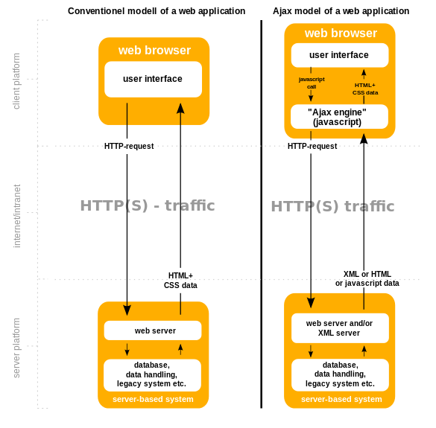

**Example**

Here is an example of a simple Ajax request using the [GET](https://en.wikipedia.org/wiki/GET_(HTTP)) method, written in [JavaScript](https://en.wikipedia.org/wiki/JavaScript).

get-ajax-data.js:

*// This is the client-side script.*

*// Initialize the Http request.*

**var**xhr=**new**XMLHttpRequest ();

xhr.open ('get','send-ajax-data.php');

*// Track the state changes of the request.*

xhr.onreadystatechange=**function**(){

**var**DONE=4;*// readyState 4 means the request is done.*

**var**OK=200;*// status 200 is a successful return.*

**if**(xhr.readyState===DONE){

**if**(xhr.status===OK){

alert (xhr.responseText);*// 'This is the returned text.'*

}**else**{

alert ('Error: '+xhr.status);*// An error occurred during the request.*

}

}

};

*// Send the request to send-ajax-data.* xhr.send (**null**);

# **6.4 What is Mongo DB?**

MongoDB is one of the [database](http://searchsqlserver.techtarget.com/definition/database) type which lies under the [NoSQL](http://searchdatamanagement.techtarget.com/definition/NoSQL-Not-Only-SQL) banner. Instead of using [tables](http://searchsoa.techtarget.com/definition/table) and [rows](http://searchoracle.techtarget.com/definition/row) as in [relational databases](http://searchsqlserver.techtarget.com/definition/relational-database), MongoDB is built on anarchitecture of collections and documents. Documents comprise sets of [key-value pairs](http://searchenterprisedesktop.techtarget.com/definition/key-value-pair) and arethe basic unit of data in MongoDB. Collections contain sets of documents and function as the equivalent of relational database tables.

MongoDB supports dynamic [schema](http://searchsqlserver.techtarget.com/definition/schema) design, allowing the documents in a collection to have different fields and structures. The database uses a document storage and data interchange format called BSON, which provides a binary representation of [JSON](http://searchwindevelopment.techtarget.com/definition/JSON-Javascript-Object-Notation)-like documents. Automatic [sharding](http://searchcloudcomputing.techtarget.com/definition/sharding) enables data in a collection to be distributed across multiple systems for horizontal as data [volumes](http://searchstorage.techtarget.com/definition/volume) increase.

# **Main Features**

Some of the features include:

* **Document-oriented**

Instead of taking a business subject and breaking it up into multiple relational structures, MongoDB can store the business subject in the minimal number of documents. For example, instead of storing title and author information in two distinct relational structures, title, author, and other title-related information can all be stored in a single document called Book.

* **Ad hoc queries**

MongoDB supports field, range queries, regular expression searches. Queries can return specific fields of documents and also include user-defined JavaScript functions.

* **Indexing**

Any field in a MongoDB document can be [indexed](https://en.wikipedia.org/wiki/Database_index) – including within arrays and embedded documents (indices in MongoDB are conceptually similar to those in[RDBMSes](https://en.wikipedia.org/wiki/RDBMS)). Primary and secondary indices are available.

* **Replication**

MongoDB provides high availability with replica sets. A replica set consists of two or more copies of the data. Each replica set member may act in the role of primary or secondary replica at any time. The primary replica performs all writes and reads by default. Secondary replicas maintain a copy of the data of the primary using built-in replication. When a primary replica fails, the replica set automatically conducts an election process to determine which secondary should become the primary. Secondaries can optionally perform read operations, but that data is eventually consistent by default.

* **Load balancing**

MongoDB scales horizontally using [sharding](https://en.wikipedia.org/wiki/Sharding). The user chooses a shard key, which determines how the data in a collection will be distributed. The data is split into ranges (based on the shard key) and distributed across multiple shards. (A shard is a master with one or more slaves.). Alternatively, the shard key can be hashed to map to a shard – enabling an even data distribution.

MongoDB can run over multiple servers, balancing the load and/or duplicating data to keep the system up and running in case of hardware failure. MongoDB is easy to deploy, and new machines can be added to a running database.

* **File storage**

MongoDB can be used as a [file system](https://en.wikipedia.org/wiki/File_system), taking advantage of load balancing and data replication features over multiple machines for storing files.

This function, called [Grid File System](https://en.wikipedia.org/wiki/Grid_File_System), is included with MongoDB drivers and available for many development languages (see "[Language Support](https://en.wikipedia.org/wiki/MongoDB#Language_support)" for a list of supported languages).

In a multi-machine MongoDB system, files can be distributed and copied multiple times between machines transparently, thus effectively creating a load-balanced and fault-tolerant system.

* **Aggregation**

[MapReduce](https://en.wikipedia.org/wiki/MapReduce) can be used for batch processing of data and aggregation operations.

The aggregation framework enables users to obtain the kind of results for which the [SQL](https://en.wikipedia.org/wiki/SQL) GROUP BY clause is used. Aggregation operators can be strung together to form a pipeline – analogous to [Unix pipes](https://en.wikipedia.org/wiki/Pipeline_(Unix)). The aggregation framework includes the $lookup operator which can join documents from multiple documents.

* **Server-side JavaScript execution**

JavaScript can be used in queries, aggregation functions (such as MapReduce), and sent directly to the database to be executed.

* **Capped collections**

MongoDB supports fixed-size collections called capped collections. This type of collection maintains insertion order and, once the specified size has been reached, behaves like a [circular queue](https://en.wikipedia.org/wiki/Circular_queue).

**Conclusion**

The main reason for doing this project is solve the parking problem of our university. In University of Karachi there are limited gates and number of vehicles passing through each gate, which when checked manually raises inconvenience and also to depot five to six persons on each gate. This problem is aimed to solve through this computer program.

**References**

* <http://www.owlnet.rice.edu/~elec539/Projects97/morphjrks/moredge.html>
* <https://sisu.ut.ee/imageprocessing/book/1>
* <http://www.mathworks.com/discovery/edge-detection.html?refresh=true>
* <http://www.engineersgarage.com/articles/image-processing-tutorial-applications>
* <https://nodejs.org/en/docs/>
* <https://docs.mongodb.org/manual/contents/>
* <https://docs.mongodb.org/manual/core/crud-introduction/>
* <https://docs.mongodb.org/manual/reference/database-references/>
* <https://github.com/gulpjs/gulp/blob/master/docs/getting-started.md>
* <https://developer.mozilla.org/en-US/docs/AJAX/Getting_Started>
* <http://bootboxjs.com/#getting-started>
* <http://getbootstrap.com/components/>